# ENPM665 – Cloud Security

# Homework – 1

*Author – Syed Mohammad Ibrahim*

*UMD ID:* *iamibi*

*UID: 118428369*

*Email:* [*iamibi@umd.edu*](mailto:iamibi@umd.edu)

1. The main screen of your AWS Console showing your name at the top right

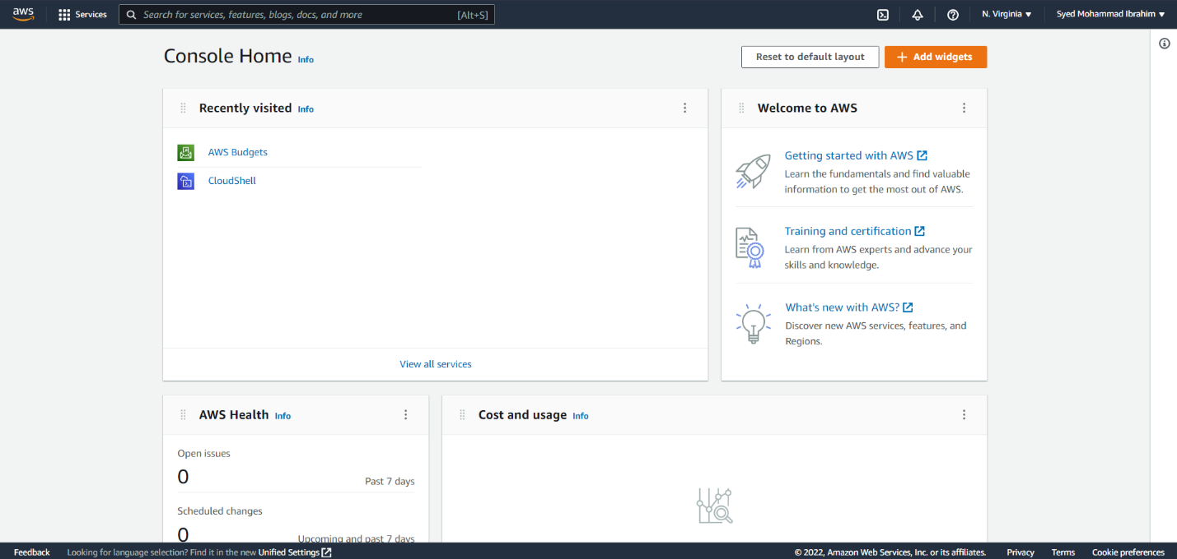

1. A screenshot of the output from running **aws iam list-users**

